30.18: a) 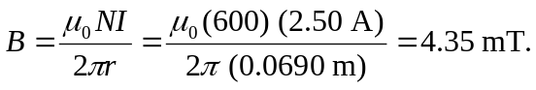
b) From Eq. (30.10), 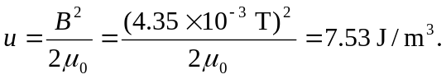
c) Volume
d)
e) 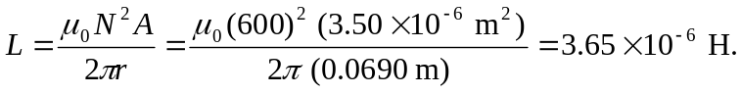
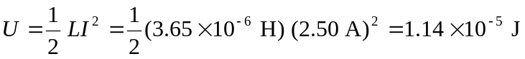same as (d).

